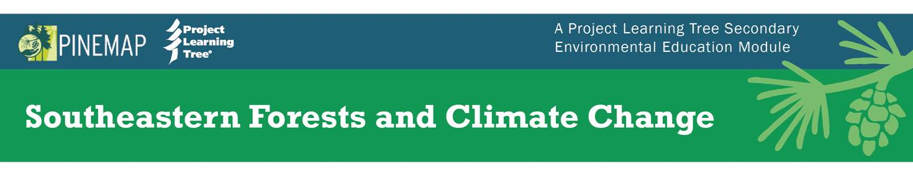
Scavenger Hunt for Walk through the Guide (2nd edition)
- Where can you find a quick glance at all the activities in the module?
The table on page 20 contains a list of the activities with a short description of each.

- Some of your workshop participants are middle school teachers. They are not sure that their students can handle these activities. What can you suggest?
They can review the Modifications section in each activity for suggestions on how to change the activity to meet their students’ needs. These ideas came from feedback provided from over 40 pilot test teachers who completed 1 to 4 activities.

- Where can you find information about common misconceptions that people hold about climate change? About forest management? What can educators do with this information?
In the Section 1 Overview. In the Section 2 Overview. Each overview contains a table of concepts that students (and adults) often find confusing. Teachers can use this information to uncover and correct misconceptions and to prompt discussion about the concept.

- What is life cycle assessment and where can you find a definition? What activities help convey this topic?
Life cycle assessment is a technique to assess the environmental aspects and potential impacts associated with all life cycle stages of a product, process, or service. The definition is in the glossary and in the Section 4 Overview. Activities 9, 10, and 11 in Section 4 focus on life cycle assessments.

- Name one activity that can be used to summarize concepts introduced throughout the module.
Any activity in Section 5 (Activities 12, 13, or 14).

- Where can you find correlations to the Next Generation Science Standards?
On the module website, under Resources for Educators.

- What are greenhouse gases? What are two example greenhouse gases? Where did you find this information?
Greenhouse gases are gases in Earth’s lower atmosphere that trap heat and affect the average temperature on Earth. Examples are carbon dioxide, chlorofluorocarbons, ozone, methane, water vapor, and nitrous oxide. This information is found in the glossary or in the background section of Activity 2 or 10.

- What is the difference between carbon sequestration and carbon storage, and which activity explains it?
Carbon sequestration is the process of capturing and storing atmospheric carbon dioxide into above or below ground carbon pools. Carbon storage is the amount of carbon that exists in a tree’s leaves and stem at a particular point in time. The glossary and Activity 8 cover this information. The definitions can also be found in the glossary.

- Your colleagues want to use these activities but can’t attend a workshop. What resources on the website can help?
Each activity contains a short “tour” or overview. There are also supplemental videos to explain concepts, and short quizzes that teachers can use to test their knowledge.

- Name three tips for teaching about climate change in the classroom.
See page 23-24 for examples.

