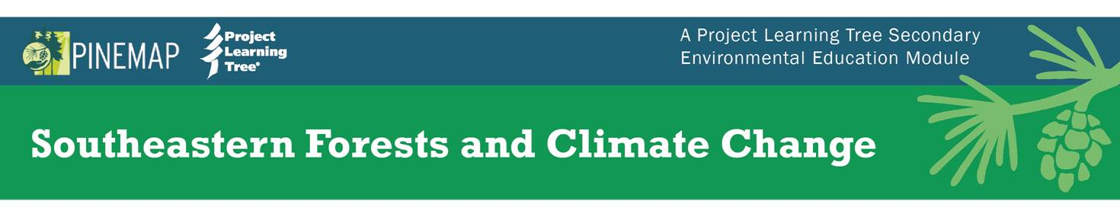
Sample Workshop Agendas
Three Hour Workshop – Focus for Biology Teachers
15 min Welcome, Introductions, Agenda Overview, Expectations
30 min Overview of Impact of Climate on Local Forests
30 min Activity 3: Atlas of Change
30 min Introduction to PLT and Module Overview
Hike through the Guide
15 min Discussion and Questions (list the ways biology could intersect with climate)
45 min Rotate through Stations
- Activity 6: Mapping Seed Sources
- Activity 7: Carbon on the Move
- Activity 8: Counting Carbon
15 min Wrap up and Evaluation

Three Hour Workshop – Focus for Social Studies Teachers
15 min Welcome, Introductions, Agenda Overview, Expectations
60 min Activity 2: Clearing the Air (with role play)
30 min Introduction to PLT and Module Overview
Hike through the Guide
60 min Rotate through Stations
Activity 9: The Real Cost
Activity 10: Adventure of Life Cycle Assessment
Activity 11: Life Cycle Assessment Debate
Activity 12: The Carbon Puzzle
15 min Wrap up and Evaluation

Three Hour Workshop – Focus for Middle School Life Science Teachers
15 min Welcome, Introductions, Agenda Overview, Expectations
30 min Overview of Impact of Climate on Local Forests
30 min Stepping through Climate Science
30 min Introduction to PLT and Module Overview
Hike through the Guide
15 min Discussion and Questions (list the ways life science could intersect with climate)
45 min Rotate through Stations
- Activity 3: Atlas of Change
- Activity 7: Carbon on the Move
- Activity 8: Counting Carbon
- Activity 9: The Real Cost
15 min Wrap up and Evaluation

Three Hour Workshop – Middle School STEM Focus
15 min Welcome, Introductions, Agenda Overview, Expectations
30 min Activity 1: Stepping through Climate Science
30 min Introduction to PLT and Module Overview (emphasize Modifications section of activities)
Hike through the Guide
30 min Activity 5: Managing Forests for Change
30 min Activity 8: Counting Carbon
30 min Intro to Activity 10: Adventures in Life Cycle Assessment
15 min Wrap up and Evaluation

Six Hour Symposium on Climate Change
30 min Welcome, Introductions, Agenda Overview, Expectations
45 min Plenary Lecture on Climate Science
15 min Questions
15 min Break
50 min Two Concurrent Sessions on Climate Science
- Public Perceptions and Why People Disagree Overview
Activity 2: Clearing the Air
- Modeling Climate and Forest Ecosystems Overview
Activity 3: Atlas of Change
10 min Switch Sessions
45 min Lunch
50 min Two Concurrent Sessions on Forest Management
  - Management Strategies for Resilient Forests Overview
Activity 5: Managing Forest for Change
  - Genetics and Breeding Overview
Activity 6: Mapping Seed Sources
10 min Switch Sessions
50 min Two Concurrent Sessions on Student Actions
  - Consumer Connections Overview
Activity 10: Adventures in Life Cycle Assessment
  - Community Action Projects Overview
Activity 14: Starting a Climate Service Learning Project
30 min Closing Plenary and Local Climate Research
15 min Questions, Wrap up, and Evaluation

